Enhancing Customer Experience with Conversational AI using Indic Languages

Abhay Singh Chauhan*, Parth Kanungo, Parth Gupta,
Binod Kumar Mishra, Kailash Chandra Bandhu, Swati Sumit Vaidya
Department of Computer Science and Engineering, Medi-Caps University, Indore, India.

Abstract— This research project aims to design and develop a voice-based conversational AI (chatbot) for customer service in the Hindi language. The chatbot is expected to handle customer queries and provide appropriate responses in real-time. The primary objective of this study is to evaluate the effectiveness of the chatbot in improving customer service and reducing response time. The project utilizes machine learning and natural language processing techniques to build an accurate and efficient chatbot. The research methodology includes data collection, data preprocessing, training, and testing. The project aims to contribute to the development of conversational AI in Indian languages and improve customer service for Hindi-speaking users.
Keywords: Conversational AI, Hindi Language, Customer Service, Chatbot, Machine Learning, Deep Learning model, RNN, Natural Language Processing, Text-to-speech, Speech-to text.

INTRODUCTION
With the advancement in technology, chatbots or virtual assistants have become popular as a means to simplify the interaction between computers and humans. A chatbot is an AI-based software that can chat or converse with a user in natural language via various platforms such as virtual chat rooms, messaging applications, websites, mobile apps or telephone. Chatbots are a type of interaction between humans and machines that are considered advanced and promising. Technologically speaking, chatbots are based on Natural Language Processing (NLP) and function as Question Answering systems that can generate natural language responses to user queries. The use of chatbots can improve the customer experience by facilitating seamless interactions with services and people. Additionally, chatbots can offer companies an opportunity to increase customer loyalty and improve operational efficiency by reducing the cost of customer service. To execute successful chatbot solutions, they need to effectively perform two basic tasks - User Request Analysis and Returning the Response.

A. User Request Analysis
The main objective of a chatbot is to examine the user's inquiry, determine their intention, and extract pertinent entities. The ability to identify the user's intent and extract relevant entities is a crucial step in the development of a chatbot. If the chatbot fails to correctly acknowledge the user's request, it will fail to provide the correct answer.

B. Returning the Response
After identifying the user's intention, the chatbot offers a suitable response to the user's inquiry. The response can either be a generic text, a text that is retrieved from a knowledge database, a piece of context-specific information that is centered on user data, or a result of an operation carried out by the chatbot after communicating with backend applications. The chatbot uses different approaches and tools depending on the application you want to address. In order to obtain the intended outcomes, the integration of various AI techniques, including machine learning, semantic comprehension, and natural language processing, could be the optimal approach. Human support plays a crucial role in training, optimizing and configuring the chatbot system.

LITERATURE REVIEW
The development of conversational agents has been one of the most important areas of research in the field of Artificial Intelligence (AI) and Natural Language Processing (NLP). One of the applications of conversational agents is to provide customer support services through chatbots, which have become increasingly popular in recent years due to their ability to provide fast and efficient assistance to customers.

Chatbots have gained significant attention in recent years, with several studies focused on their development and applications. In their paper, Chandrasekaran et al. (2018) [17] provide a comprehensive survey of the development of chatbot technology and its ability to pass the Turing test. The authors highlight the limitations of existing chatbots in understanding and responding to natural language inputs and discuss potential solutions for improving chatbot performance.

Another important aspect of chatbot development is the use of machine learning techniques. In their paper, Rahman et al. (2019) [18] provide an overview of the different machine learning techniques used for chatbot development, including rule-based systems, retrieval-based models, and generative models. The authors also discuss the advantages and disadvantages of each technique and provide recommendations for chatbot development based on the type of application.

In the context of customer support, chatbots have become an essential tool for businesses to provide quick and efficient support to their customers. In their paper, Nasir et al. (2019) [19] discuss the potential of chatbots in providing customer service and identify the key factors for successful chatbot deployment. The authors also highlight the importance of chatbot customization based on the specific needs of the business and its customers.

In their study, Shum and He (2018) [16] evaluated the effectiveness of chatbots in providing customer service for e-commerce websites. They found that chatbots were able to handle a significant portion of customer queries and reduce customer wait times. Similarly, Karami et al. (2020) [13] evaluated the use of chatbots in the banking industry and found that chatbots could improve customer satisfaction and reduce costs

Another study conducted by Wu et al. (2020) [24] proposed a multi-turn conversational model with an attention mechanism for customer support chatbots. The model was trained on a dataset of customer support conversations and achieved high accuracy in predicting customer intents and generating appropriate responses. Their approach showed that the use of attention mechanisms can significantly improve the performance of chatbots in handling complex and long conversations.

Numerous studies have shown the potential of chatbots to improve customer service and reduce response time in various domains. However, most of these studies have been conducted in English or other European languages, with very few studies focusing on chatbots in Indian languages, particularly in Hindi.

The use of chatbots in different languages has also been explored in various studies. For example, in their study, Sarker et al. (2019) [15] evaluated a chatbot system for customer support in the Bengali language. They found that the chatbot system was able to handle customer queries effectively and efficiently. Another study by Liu et al. (2018) [14] explored the use of chatbots in the Chinese language and found that the chatbot system was able to improve customer satisfaction and reduce response times.

According to a study by Google India, Hindi is the second most widely spoken language in the world after Mandarin Chinese, with more than 500 million speakers. Despite the large number of Hindi speakers, there is a significant gap in the availability of conversational agents that can provide customer support services in Hindi.

In recent years, there have been a few studies on developing conversational agents in Hindi for various applications. For example, a study by Singh et al. (2020) [11] proposed a chatbot-based system for the detection and classification of hate speech in Hindi. Another study by Anand et al. (2020) [9] developed a chatbot-based system for providing mental health support in Hindi.

In the context of chatbot development for the Hindi language, there is a lack of research studies available. In their paper, Gupta et al. (2021) [21] discuss the development of a chatbot for the Hindi language using Google Dialogflow. The authors highlight the challenges in developing a chatbot for Hindi, including the lack of language resources and the complex nature of the Hindi language. The authors also provide recommendations for future work in improving the performance of the chatbot.

Another important aspect of chatbot development is the integration of text-to-speech (TTS) and speech-to-text (STT) systems. In their paper, Nalepa et al. (2020) [20] discussed the development of a chatbot for elderly care that utilizes both TTS and STT systems. The authors highlight the importance of multi-modal chatbots in improving user experience and discuss the

challenges in developing such systems.
Similarly, another study conducted by Shafiq et al. (2019) [23] proposed a voice-based chatbot system for customer support using the Microsoft Azure Cognitive Services API. Their system was designed to understand and respond to users' queries in multiple languages, including English, Spanish, and Chinese. The authors evaluated the performance of their system through a user study and found that their voice-based chatbot was able to provide accurate and helpful responses to users' inquiries.

However, only a handful of studies have focused on creating a chatbot for customer support in the Hindi language. The development of such a chatbot is particularly important given the increasing use of online platforms for customer support services and the need for businesses to cater to Hindi-speaking customers.

In addition, we integrated Google TTS technology to provide a voice-based interface for our chatbot. Several studies have explored the use of TTS technology in chatbots. For example, in their study, Kim et al. (2019) [12] evaluated the effectiveness of TTS technology in chatbots for the Korean language. They found that TTS technology could improve the overall user experience of the chatbot system.

Overall, the use of deep learning models and TTS technology in chatbots has shown promising results in various studies. In the context of the Hindi language, our chatbot implementation is one of the few studies that have explored the use of such technologies for customer support services. Our approach can be extended to other languages as well, to provide efficient and effective customer support services in different parts of the world.

Authors and Year | Focus of Study | Key Findings
Chandrasekaran et al. (2018) [17] | Development and ability of chatbots to pass the Turing test | Existing chatbots have limitations in understanding and responding to natural language inputs; potential solutions for improving chatbot performance
Liu et al. (2018) [14] | Use of chatbots in the Chinese language | Chatbot system can improve customer satisfaction and reduce response times
Shum and He (2018) [16] | Effectiveness of chatbots in providing customer service for e-commerce websites | Chatbots can handle a significant portion of customer queries and reduce customer wait times
Sarker et al. (2019) [15] | Chatbot system for customer support in the Bengali language | Chatbot system can handle customer queries effectively and efficiently
Rahman et al. (2019) [18] | Machine learning techniques used for chatbot development | Overview of rule-based systems, retrieval-based models, and generative models; advantages and disadvantages of each technique
Nasir et al. (2019) [19] | Potential of chatbots in providing customer service | Chatbots are an essential tool for businesses to provide quick and efficient support to customers; key factors for successful chatbot deployment; importance of chatbot customization
Karami et al. (2020) [13] | Use of chatbots in the banking industry | Chatbots can improve customer satisfaction and reduce costs
Liu et al. (2020) [10] | Development of a chatbot for customer service in the English language | Chatbot system can handle a wide range of customer queries and improve customer satisfaction
Singh et al. (2020) [11] | Chatbot-based system for detecting and classifying hate speech in Hindi | Use of chatbot technology for social issues in Hindi
Anand et al. (2020) [9] | Chatbot-based system for providing mental health support in Hindi | Use of chatbot technology for mental health support in Hindi
Nalepa et al. (2020) [20] | Development of a chatbot for elderly care using TTS and STT systems | Importance of multi-modal chatbots in improving user experience; challenges in developing such systems
Wu et al. (2020) [24] | Multi-turn conversational model for customer support chatbots | Use of attention mechanisms can significantly improve the performance of chatbots in handling complex and long conversations
Shafiq et al. (2019) [23] | Voice-based chatbot system for customer support in multiple languages | System can understand and respond to users' queries in multiple languages, including English, Spanish, and Chinese
Gupta et al. (2021) [21] | Development of a chatbot for the Hindi language using Google Dialogflow | Challenges in developing a chatbot for Hindi; lack of language resources and complex nature of the Hindi language

PROBLEM STATEMENT AND OBJECTIVE

The problem statement is that with the increasing number of services, the number of customer queries related to a particular service is also increasing rapidly. To provide solutions to these queries, companies are hiring a huge number of employees that can work as customer support. However, this process of providing solutions to customers is slow and expensive. Therefore, there is a need for a solution that is feasible and accessible to everyone.

The project involves creating two inter-dependent modules: a chatbot and a server based on deep learning models

The chatbot component will possess the following features:
- Designed using natural language processing (NLP) technology
- Capable of engaging customers through voice communication
- Enabled to grasp and comprehend the Hindi language with the aid of NLP

The server module will encompass the following functionalities:
- Conduct pre-processing of customer queries

- Perform query processing utilizing machine learning (ML) and NLP engine to provide customers with appropriate solutions
- Acquire learning and understanding capabilities via ML and NLP engine.

SCOPE & OVERVIEW

Justification:
In India, numerous queries are received on a daily basis across various sectors, such as telecommunications, financial services, and banking. Hiring a large number of employees for customer support can be expensive for companies. However, most of the queries are often repetitive and common. Using a chatbot can be a cost-effective solution for companies to handle similar queries and reduce expenses. Moreover, chatbots provide several advantages over manual support systems, such as:
- Availability 24/7.
- Instant communication.
- Reduced costs.
- Tailored solutions.

Product scope description:
- The product must classify query types and provide appropriate solutions.
- The product must redirect the user to a support admin and train itself for new queries for future use.

Acceptance Criteria:
- The product must identify whether the query is related to the product delivery domain or not.
- All modules used to develop the bot must work synchronously.
- The product must facilitate fast interactions between the user and itself.

Deliverables:
- Segregation of queries related to the product delivery domain and other domains.
- Identification of the most frequently asked queries and training of the chatbot to provide more tailored solutions.
- The product must redirect the user to a support admin if the chatbot is unable to provide a solution to a query related to the product delivery domain.

Assumptions:
- The server has NVIDIA GPU support.
- The GPU drivers for TensorFlow are current.
- The chatbot has been trained beforehand.
- The queries are pre-defined.

PROPOSED SYSTEM

The system that has been proposed will include the following elements:

- TensorFlow: This API is fast and easy to use for image recognition on a computer or laptop, even without a GPU. The pre-trained models can be adapted to new data classes, which provides several advantages.

- Flask: This is a Python-based micro web framework that doesn't require specific tools or libraries. Although the chatbot does not include any database abstraction layer or form validation, these functionalities can be obtained through third-party libraries that offer such common functions.

- HTML, CSS, and JavaScript: These technologies are useful for front-end development and building user interfaces or UI components.

- Natural Language Processing (NLP): This is a subfield of linguistics, computer science, and artificial intelligence that focuses on how computers can process and analyze large amounts of natural language data, enabling the chatbot to understand customer queries and provide appropriate responses.

DESIGN DETAILS

The proposed system's design process involves the following steps:

- Step 1: Query Acceptance
The Chatbot will accept queries from any user.

- Step 2: Query Analysis
The Chatbot will analyze the user's query and search for the best solution for it in the database.

- Step 3: Query Response
The Chatbot will provide a solution to the user's query based on the training data.

Use Case Diagram
A use case diagram is a graphical representation that shows how a user interacts with the system and the different use cases involved in that interaction. This aids in comprehending the functional prerequisites of the system as well as the connection between the user and the system.

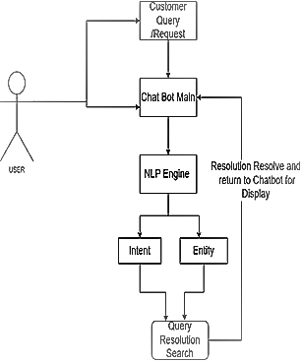
- Use Case Diagram.

 | Details of Hardware and Software
 | Operating System | Windows 7/8/8.1/10, Linux
 | Tools and Framework |  | VS Code, TensorFlow, Flask, HTML, CSS and JavaScript
 | Language Requirement | Python, JavaScript
 | Server | Locally hosted
- Table for Requirements.

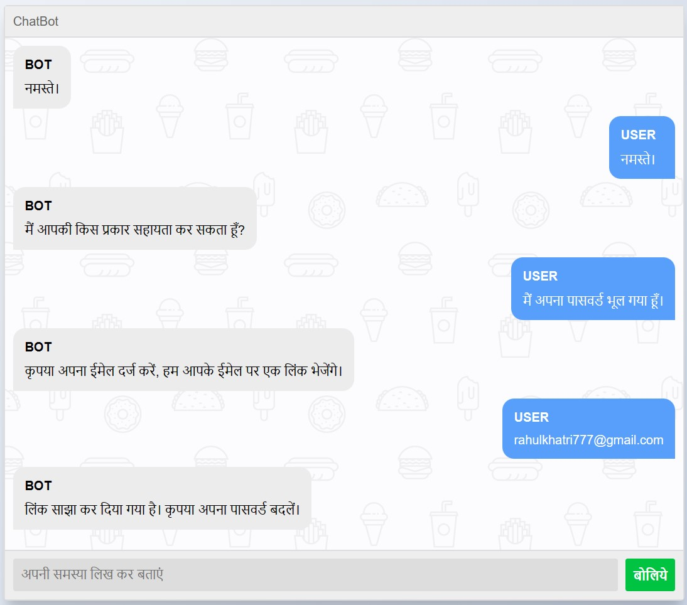
- Demo User Interface.

RESULT
Result of hyperparameter tuning.

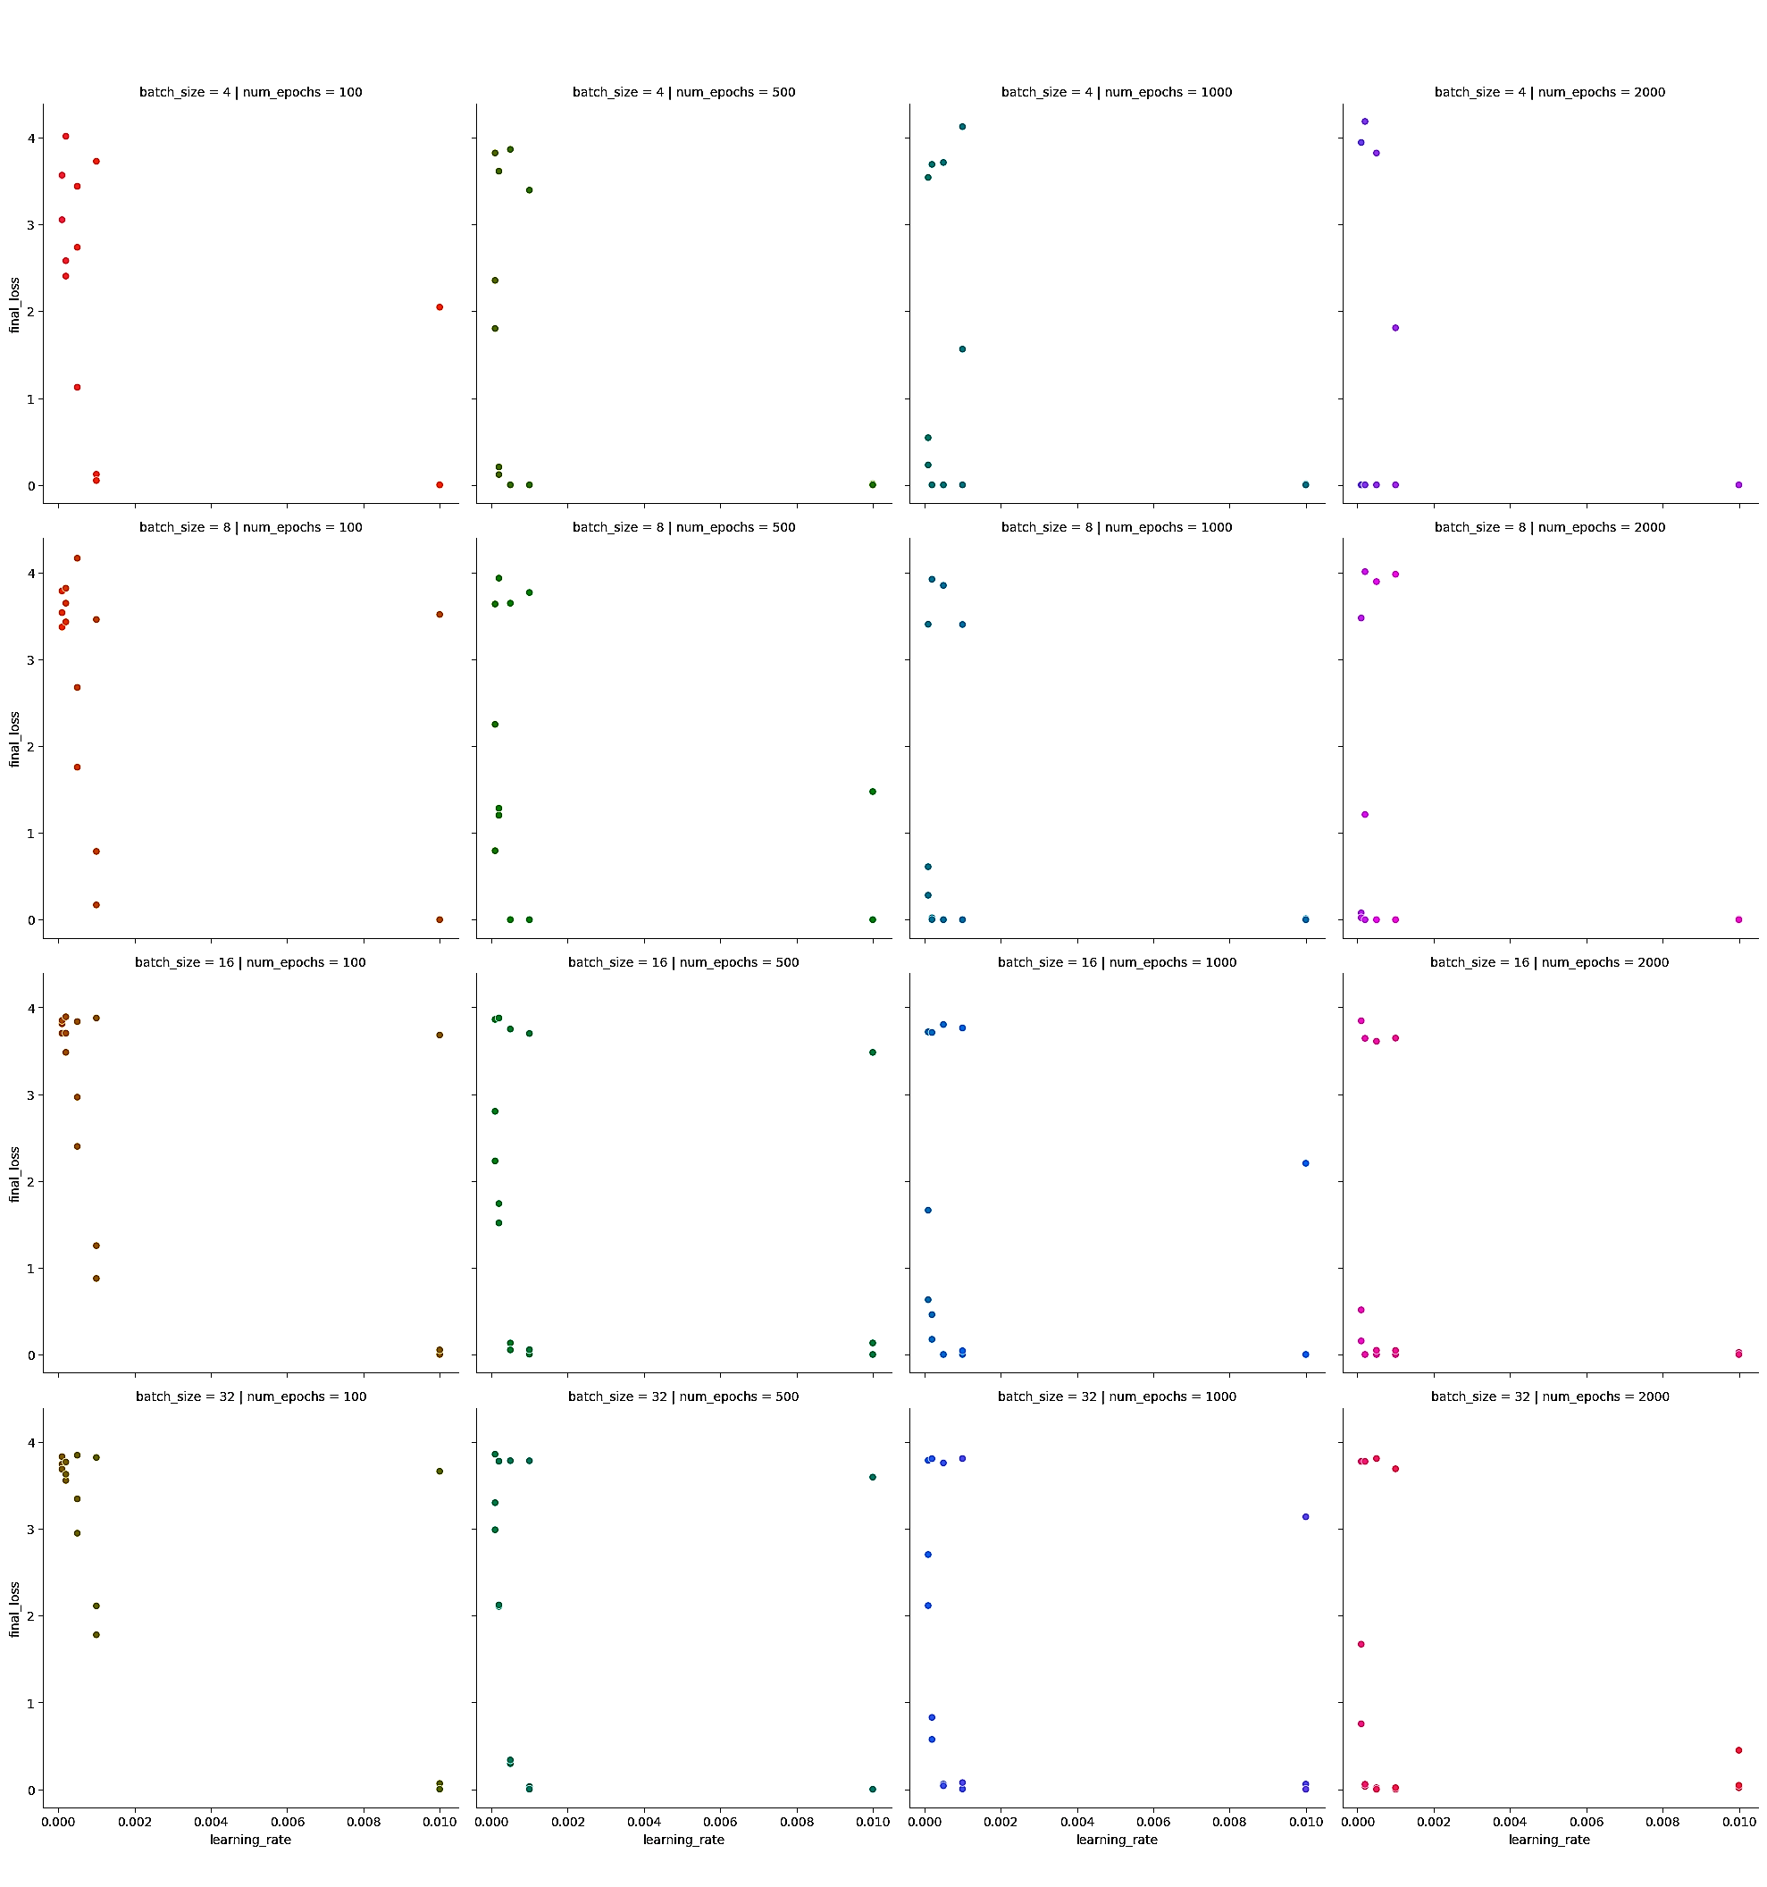

- Hyperparameter tuning graph.

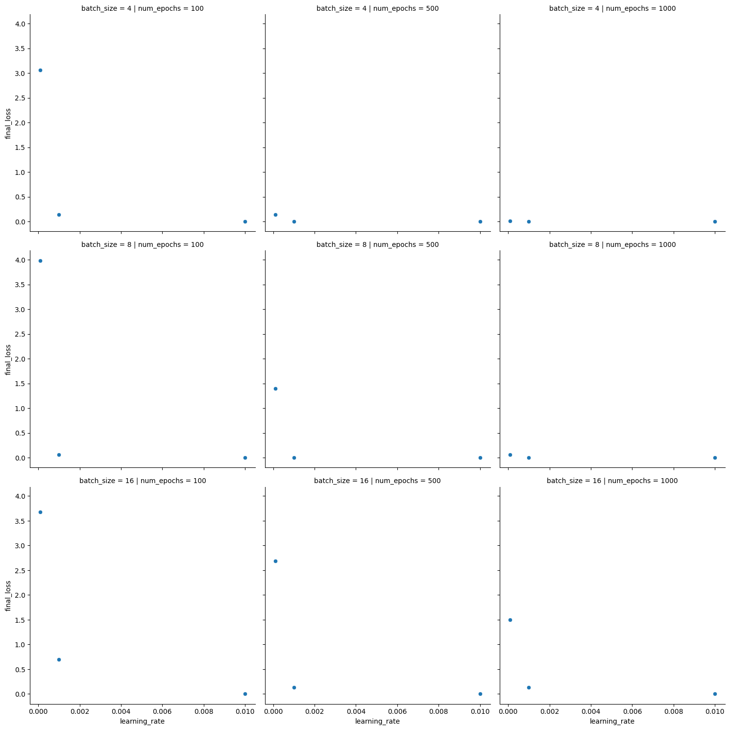

- Hyperparameter tuning graph using ADAM optimizer.

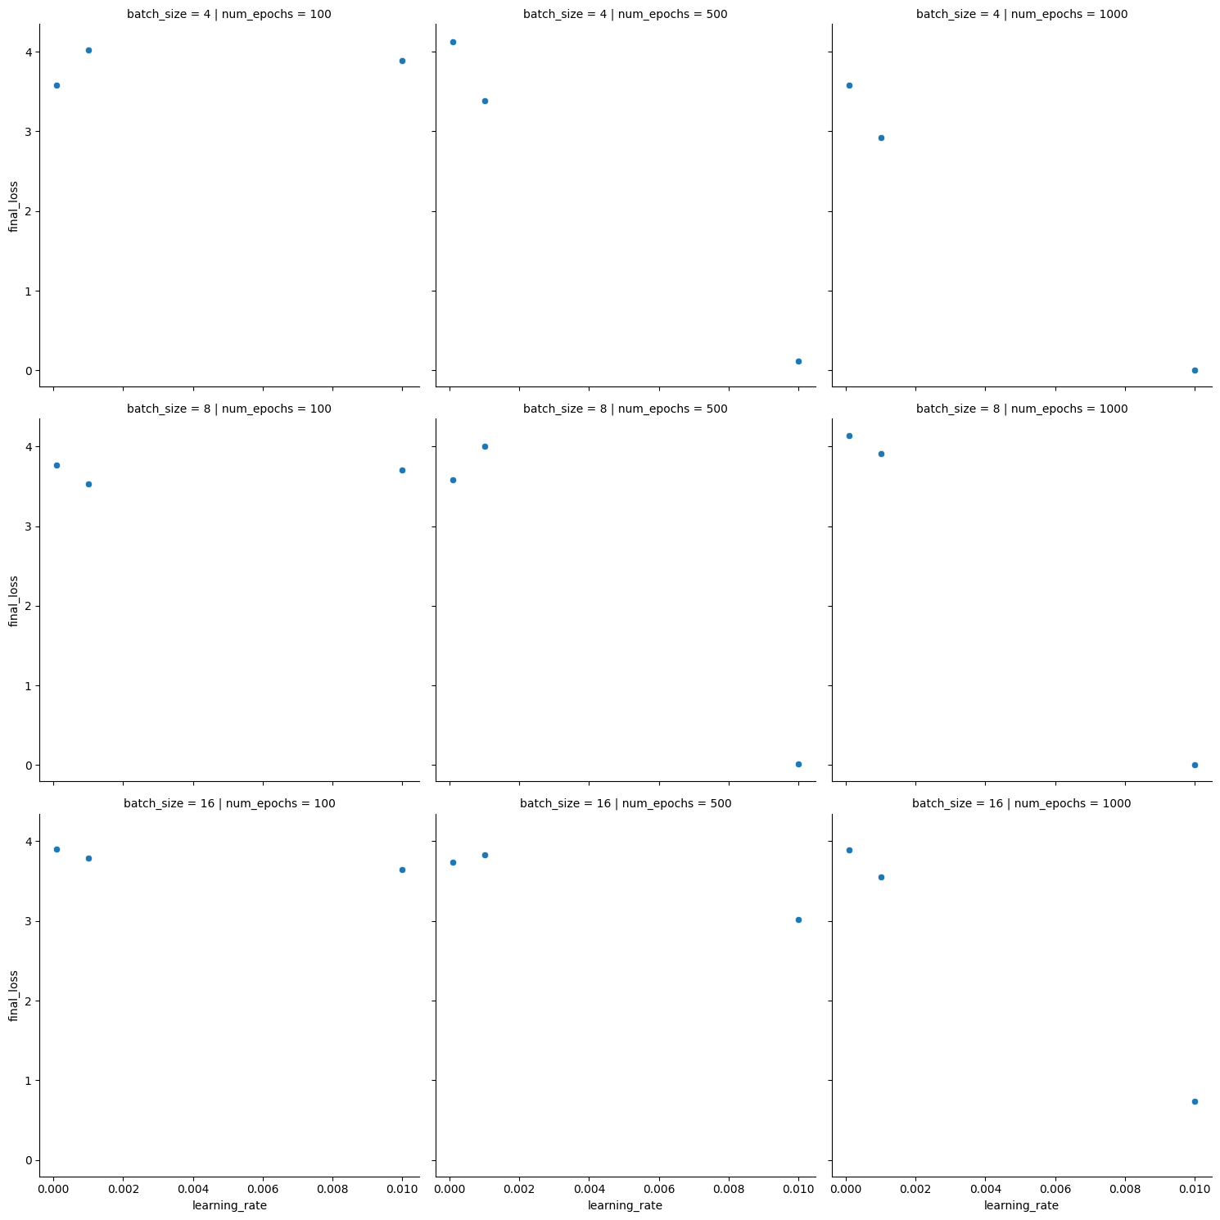

- Hyperparameter tuning graph using SGD optimizer.

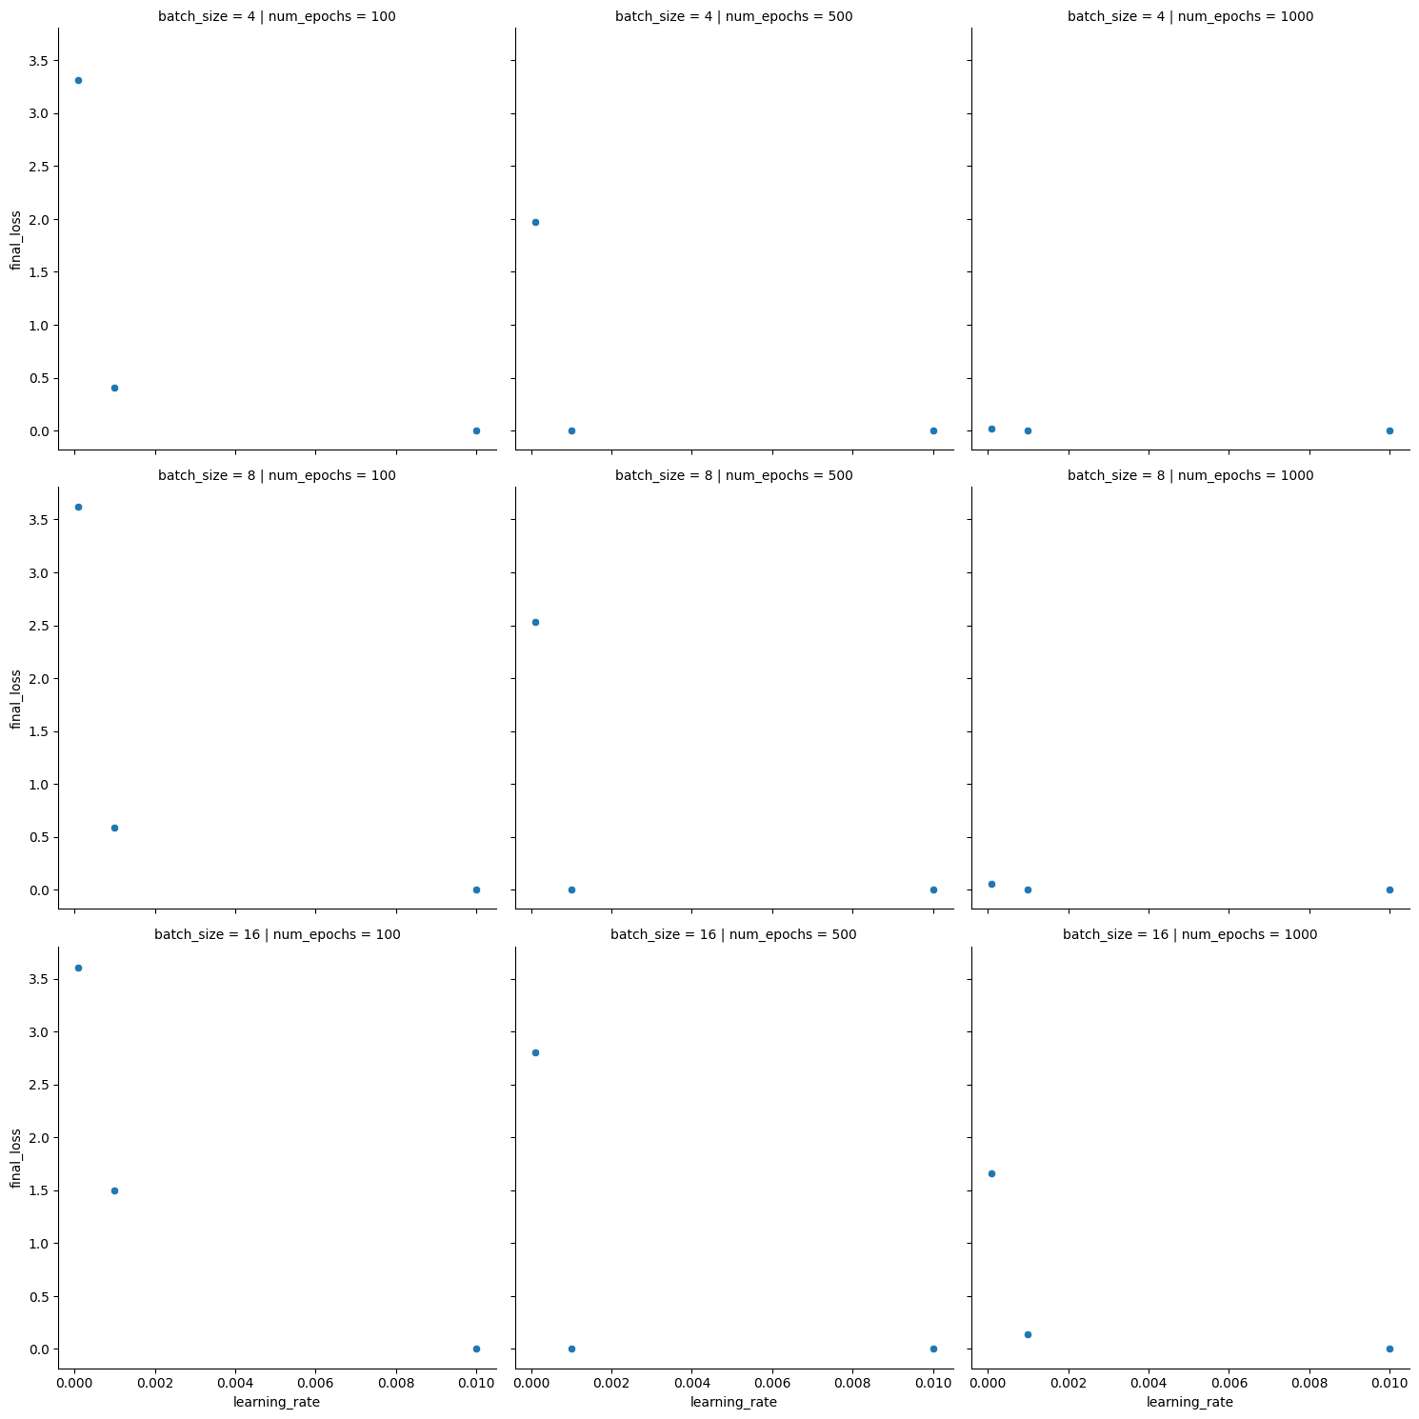
- Hyperparameter tuning graph using RMSprop optimizer.

CONCLUSIONS

In this paper, voice based in reference with this study, a prototype of a customer support chatbot is developed along with a software and framework analysis report. The chatbot is designed to process user queries and determine the query type, providing an optimal solution for the user. The chatbot will have a database containing most of the queries related to product delivery and provide solutions as quickly as possible. To improve its knowledge, the chatbot will use natural language processing to train itself on new queries.

REFERENCES

- Dialogflow Documentation | Google Cloud https://cloud.google.com/dialogflow/docs

- Khan, R., & Das, A. (2018). A complete guide to getting started with chatbots. Springer.

- Jain, M., Kumar, P., Kota, R., & Patel, S. N. (2018). Evaluating and informing the design of chatbots. Proceedings of the 2018 Designing …, ACM.

- Smutny, P., & Schreiberova, P. (2020). Chatbots for learning: A review of educational chatbots for the Facebook Messenger. Computers & Education, Elsevier.

- Di Gaetano, S., & Diliberto, P. (2018). Chatbots and conversational interfaces: Three domains of use. Fifth International Workshop on Cultures of …, ceur-ws.org.

- A Psychologist Chatbot Developing Experience - CEUR-WS.org

- Berrón-Pérez, R., Guerrero-Ibáñez, J. J., Gallegos-Funes, F. J., & de la Vega-Funes, G. (2019). Methodology for the Implementation of Virtual Assistants for Education Using Google Dialogflow. ResearchGate.

- Khan, A., Khan, M., & Utekar, R. (2021). Customer support chatbot using NLU. International Research Journal of Engineering and Technology.

- Anand, A., A. K., & Gupta, V. (2020). Chatbot Based Mental Health Support System in Hindi. International Journal of Computer Science and Information Security, 18(6), 201-208.

- Google India. (2018). Indian Language Internet Users to Reach 536 Million by 2021, Says New Report.

- Singh, S., Singh, R., Kumar, S., & Singh, R. (2020). Chatbot-Based System for Detection and Classification of Hate Speech in Hindi Language. In the International Conference on Machine Learning, Big Data, Cloud and Parallel Computing (pp. 139-144). Springer, Singapore.

- Kim, M., Lee, J., & Lee, H. (2019). Design and implementation of voicebot with TTS for customer service. Journal of Software Engineering and Applications, 12(5), 228-237.

- Karami, A., Nasiri, R., & Shalileh, M. (2020). Customer service chatbots in banking industry: A comprehensive review. Journal of Retailing and Consumer Services, 52, 101921.
- karf, B., Li, J., Li, X., Li, Y., & Li, Q. (2018). The design and implementation of a customer service chatbot system based on the state-transition model. In Proceedings of the 10th International Conference on Machine Learning and Computing (pp. 286-292).

- Sarker, S., Mukherjee, S., Das, A., Das, D., & Bandyopadhyay, S. (2019). A customer support chatbot for Bengali language. In 2019 6th International Conference on Signal Processing and Integrated Networks (SPIN) (pp. 78-83).

- Shum, P. K., & He, Y. (2018). Chatbots and customer service: A case study. In Proceedings of the 13th International Conference on Computer Science and Education (ICCSE) (pp. 104-108)

- Chandrasekaran, A., et al. (2018). "A Survey of Chatbot Technology through the Lens of the Turing Test." Computers 7(3): 49. doi: 10.3390/computers7030049

- Rahman, M. M., et al. (2019). "Chatbot Design and Deployment: A Survey." IEEE Transactions on Computational Social Systems 6(3): 530-539. doi: 10.1109/TCSS.2019.2914817

- Nasir, M., et al. (2019). "Chatbots for Customer Service: An Entrepreneurial Opportunity." Journal of Innovation and Knowledge 4(4): 180-187. doi: 10.1016/j.jik.2019.07.003

- Nalepa, G. J., et al. (2020). "Developing a Multi-Modal Chatbot for Elderly Care." Journal of Ambient Intelligence and Humanized Computing 11(9): 3609-3621. doi: 10.1007/s12652-020-02725-3

- Gupta, A., et al. (2021). "Development of a Chatbot for Hindi Language using Google Dialogflow." International Journal of Scientific and Technology Research 10(1): 134-137.

- Kang, M., & Kim, S. (2019). Design and Implementation of Voice-based Customer Support Chatbot System. International Journal of Engineering and Advanced Technology, 8(1), 545-551.

- Shafiq, M. O., Al-Shahrani, M., Alshahrani, A., Aljaffan, N., Almehmadi, F., & Albalawi, N. (2019). Development of Voice-based Chatbot System for Customer Support using Microsoft Azure Cognitive Services. International Journal of Advanced Computer Science and Applications, 10(9), 18-25.

- Wu, S., Wang, X., Li, Y., Huang, Y., & Wu, Z. (2020). A Multi-turn Conversational Model with Attention Mechanism for Customer Support Chatbots. Journal of Physics: Conference Series, 1521(3), 032069.

